# CS 340 README

## About the Project/Project Title

*This project allows an authorized user to access a database of information about animals at a shelter. It will allow the user to perform the basic CRUD (create, read, update, delete) functions on the database. Using these functions, I built a dashboard that displays the data in a meaningful way.*

## Motivation

*The motivation for this project is to develop an interactive dashboard for the client, Grazioso Salvare, which allows their employees to better serve their needs as an animal rescue.*

## Getting Started

1. *Enter the MongoDB shell using a command terminal.*
2. *Import the csv file (aac_shelter_outcomes.csv)*
3. *Provide username and password for authentication.*
4. *User needs access to Python to run the program*

## Installation

*Current version of MongoDB*

*Current version of Python*

*CRUD .py file*

*Dashboard .ipnyb file*

*Jupyter Notebook*

*MongoDB was chosen for it’s ease of use with Python scripts using it’s driver, PyMongo. MongoDB is flexible and is easily scalable. Dash has useful features for building interactive dashboards that were suitable for this project.*

## Usage

### Code Example

* Create – creates and inserts a new animal to the database.

* Read – finds and displays data for an animal query

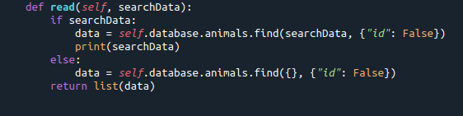

* Update – finds and updates information on an existing animal in database

* Delete – finds and deletes an existing animal from database

### Tests

### Screenshots

**Challenges:**

*It took me forever to figure out why my dashboard would crash when I attempted to add the map. I had to remove functionality and slowly add it back until I got the entire map to work. I still did not get my pop-ups to display the way I wanted them to, but I think the dashboard I created works well for what it needs to do.*

## Contact

Your name: Mary Sanders